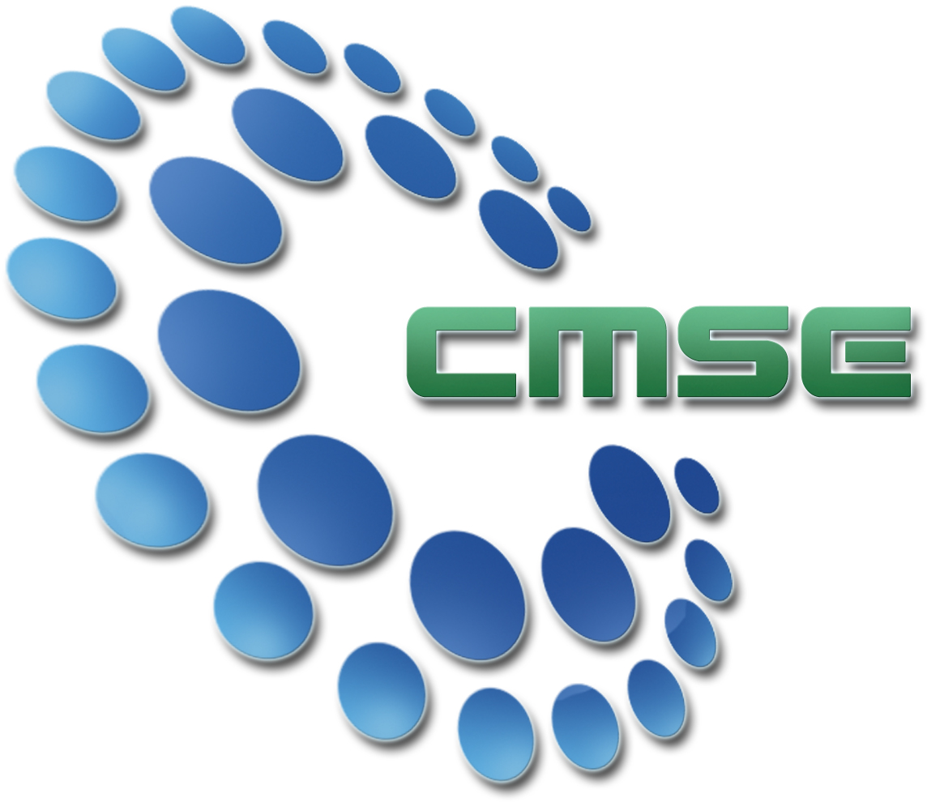Mark Your Calendars

The Center for Macromolecular Science and Engineering is hosting its 2008 Symposium and Poster Session

January 17, 2008

Symposium held in Leigh Hall 207
5:00-6:45 pm

Poster Session held in Ustler Hall Atrium
7:00-9:00 pm

*Invited speakers include Dr. Jeff Moore (University of Illinois), Dr. Harry Gibson (Virginia Tech), and Dr. Eric Moskala (Eastman Chemical Company)*

*Three $300 cash prizes will be awarded to the top poster entries*
*Hors d’oeuvres, dessert, and beverages will be served during the poster session*

For more information contact Sara Klossner: klossner@chem.ufl.edu -or- 352.392-2012

